2nd ANNUAL
JACK SMITH MEMORIAL
GOLF OUTING
SATURDAY, JUNE 2, 2018
MIDDLECREEK GOLF COURSE
ARRIVE AT 8:00 AM, TEE OFF AT 8:30 AM
4 MAN SCRAMBLE -SHOTGUN START – 16 TEAMS OF 4
$60 PER GOLFER/$240 TEAM - INCLUDES LUNCH
PAY FOR KICKERS/POWER-UPS/MULLIGANS SEPARATELY
TO REGISTER CALL THE PROSHOP: 814-926-2067

TEAM PRIZES
FIRST PLACE - $400
SECOND PLACE - $200
THIRD PLACE – 18 HOLES W/CART FOR 4 @ MIDDLECREEK GOLF
In loving memory of Jack Smith

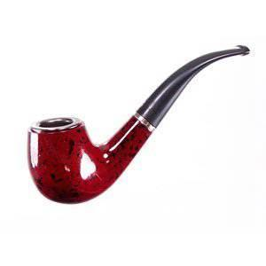
ALL PROCEEDS WILL BE DONATED TO THE ROCKWOOD GOLF TEAM

